In this lesson we will see how to create react native app
We will write some code and bring some change to it.
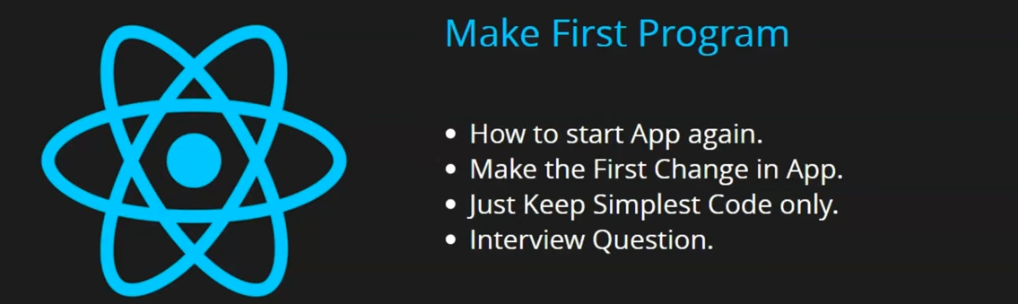
It will help you to gain confidence
we will know after doing everything to run our app and develop it and closing it how to restart it all(starting the app again)(I don't know)
We will make the first changes in our app.
We will keep the code simple and remove all the extra code to keep the app simple
by this you will get the confidence that's how we can build our small simple code.
At last Teacher will ask some important interview questions.
You don't need to open Android studio to open emulator to open your app
just run the cammand "npm run android" in cmd.
and then your emulator will be opened without having to open android studio and run it seperately.
We will just edit the index.tsx file as shown below so we just remove the file explorer.
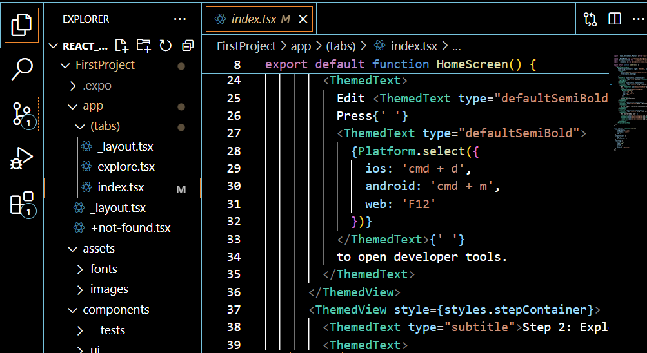
The whole project structure you will see it in the next lessons
you will see what file is used for what purposes
Note:-
When the app run in phone or maybe emulator it start binding and then starts the game(I don't know).
Once the app runs in your system then after it environment has succesfully set up
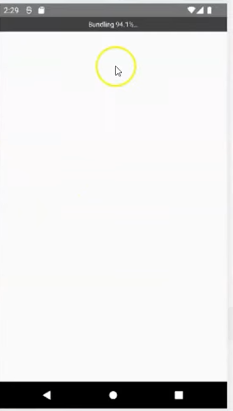
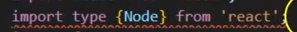
If in your index.tsx there is a line as above in top then remove it as it is used in typescript and we are not using javascript.
Remove the Node word anywhere in that file.
Make file index.tsx simple by removing the tag in return and remove the unnecessary things.
______________________________________
Note:-
Your UI or pp may crash while editing the file associated with app(sometimes it happen according to the teacher(I don't know))
I think if there is no bundling showing in the screen then the screen will not be updated with the code or maybe it is due to the cammand did not run in a correct way due to lack of screen presense or maybe other person.
______________________________________
As I have studied react there will be tags used in the return of the function
So In react native we have tag called View tag
Unlike react we cannot use html elements in react native
Here you need to use component inplace of html elements
You can use <></> in place of View Tag we have another tag to write structures text called Text tag.
To use view and Text component we need to import it from React native.
But one thing is similar that is style attribute
but this style attribute is valid for some Text like in Text tag
Now our code look like below
import react from 'react'
import {Text, View} from 'react-native'
export default function HomeScreen() {
return (
<View>
<Text style={{fontSize:30,color:"red"}}>Hello React Native</Text>
</View>
);
}
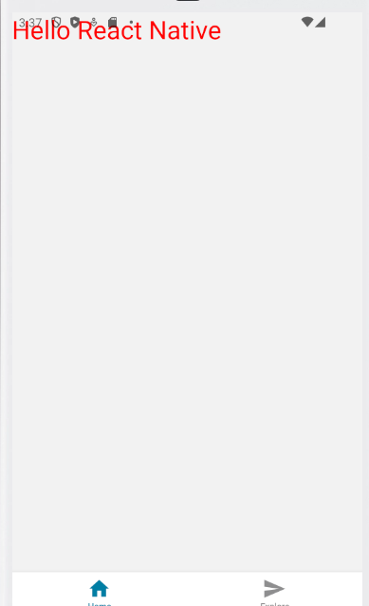
Output:-
__________________________________________
Note:-
1. If there is some error occured in your app its detail will be seen in the output screen or in cmd.
2. React native is actually a framework
3. We can also include CSS in our React Native
__________________________________________
We will see the whole structure of react native project in upcoming chapter.
We will also remove the the files which we willnot needed

Interview Question:-
What is the difference between React and React native

In next lesson we will see the architecture of our project and we will see what file is used for what work.
We see in future Howto make a component and How to use states an props. We will see all of these one by one.
The difference between a framework and a library lies primarily in the way they are used in software development and how they structure the flow of a program.

1. Inversion of Control:
- Framework:
  - In a framework, the framework controls the flow of the application. You write specific pieces of code that fit into the framework’s structure, but the framework dictates how and when those pieces of code are executed.
  - It's sometimes described as "Hollywood Principle" — "Don't call us, we'll call you."
- Library:
  - In a library, you control the flow. You choose when and where to call the functions or features of the library in your application.
  - You are in charge of integrating the library into your program.

2. Usage:
- Framework:
  - A framework typically provides a full structure for your application, offering a skeleton with pre-defined ways to build your software. This includes things like pre-configured workflows, templates, or even entire architecture for a web app, game, or mobile app.
  - Example: Angular (JavaScript framework), Django (Python framework), Spring (Java framework).
- Library:
  - A library is more focused and provides a set of tools or functions to accomplish specific tasks without enforcing a structure. It is up to the developer to integrate the library within their application as needed.
  - Example: jQuery (JavaScript library), NumPy (Python library), OpenCV (computer vision library).

3. Flexibility:
- Framework:
  - Frameworks tend to be more opinionated, meaning they come with pre-decided rules, guidelines, and patterns that developers must follow. This reduces flexibility but improves consistency and structure.
- Library:
  - Libraries are generally more flexible. You can pick and choose how to use them in your project. They offer solutions to specific problems without imposing rules on your application architecture.

4. Size:
- Framework:
  - Frameworks are usually larger because they include tools, conventions, and structures designed to help build entire applications.
- Library:
  - Libraries are generally smaller, focused on specific tasks, and often can be used in various different frameworks or applications.

5. Examples:
- Framework:
  - Angular (JavaScript web framework), Django (Python web framework), Spring (Java enterprise framework).
- Library:
  - React (JavaScript library for building user interfaces), Lodash (JavaScript utility library), Matplotlib (Python plotting library).

Summary:
- Framework: A complete, structured environment where the framework controls the flow of the program. It's an all-encompassing solution for building an application.
- Library: A set of reusable, focused tools or functions that you integrate into your application as needed. You control the flow of the program.
In short, a framework dictates the architecture of your application, while a library gives you tools that you can use as needed without enforcing specific structures.

